Agenda
Aug. 1, 2018 at 2 p.m. ET
Communications Committee

ATTENDEES
Task Group Members: Marsha Wilson, John Brookey, Cait Ellis, Paige Cucchi, Debbie Saslow, Lisa Paradis, Susan Martin, Greg Zimet, Ian Branam, Elizabeth Ryan,

Not able to join: Kelli Vos, Aubrey Villalobos, Katherine Nicol, Lacey Eden. Amy Pisani, Tamika Felder, Christine Baze, Electra Paskett, Elizabeth Langdon, Greg Yoder, Kerri Lopez, Mary Rubin, Marla Dalton

- Updates from members – Round Robin
  - Greg Zimet (Society for Adolescent Health and Medicine)– shared the campaign with SAHM and will follow-up with them. VP Joe Biden cancer initiative convened several HPV Roundtable members including Drs. Brewer, Perkins, Zimet and Saslow to ask them, “What would be the best and most effective way to make use of [the Biden] star power to increase HPV vaccine uptake. Idea 1: convene 3rd party payors to reduce remaining barriers to vaccination. Still reports of it being hard to maintain HPV vaccine supply at small practices. Idea 2: Use Joe/Jill Biden influence to share personal narratives. The next steps include follow-up calls.
  - Paige Cucchi (Corp Comm, ACS) – Mission: HPV Cancer Free has launched and the next steps include brainstorm/strategic planning around what campaign will look like going forward.
  - Lisa Paradis (President’s Cancer Panel) – update of the 2014 HPV report chaired by Dr. Barbara Rimer (UNC). Report is in review and they are aiming for a release in late September.
  - John Brookey (Kaiser) – met with regional Chief of Pediatrics and shared the provider toolkit with all the Chiefs of Pediatrics within Kaiser. Also, Pediatric and GYN Oncology are putting together a regional workgroup to increase HPV rates. They are considering resources, including the possibility of making their own. Kaiser P. really trying to increase HPV vaccination rates.
  - Cait Ellis (National Institute for Health Care Management)– NIHCM quarterly newsletter coming up. Will share Power campaign in the newsletter.
  - Susan (AAP) – Promoting the HPV campaign with AAP members and through public platforms. As part of larger NIAM push, AAP has developed a new PSA that is on social and tv that focuses on adolescent immunization panel. Please visit Healthychildren.org Facebook page and like and share.
  - Ian Branam (CDC) – Summer provider and consumer media campaign on HPV are ongoing. Provider – through August; Consumer – through September. Reach out to Ian if you are not subscribed to their e-newsletter. Included promotion to Power to Prevent in latest newsletter. Adding to the #HowIrecommend video resource library; including family physicians and Nurse Practitioners. Congrats to LACEY EDEN for participating!
- Updates on 2018 Power to Prevent HPV Cancer – Jennifer Sienko
**Please let me know if you are interested in working on project group to evaluate this campaign. **
- /Power - 3,521 pageviews July 2018 (34.37% of total pageviews)
- 1,711 Sessions (period of time a user is actively engaged with your website)
  - 83.46% of sessions were new sessions (estimation of first time visits)
  - 1428 New Users
  - 00:01:39 Average Session Duration
- 53.22% of people visiting HPVRoundtable.org entered through our /Power page
- Weekly emails for July
  - Total of 3,424 emails delivered in July
  - Week 1 – Announcement
    - 850 emails delivered
    - 2,228 total opens (354 unique opens)
    - 395 total forwards (102 unique forwards)
  - Week 2 – Office Staff
    - 847 emails delivered
    - 2,521 total opens (314 unique opens)
    - 424 total forwards (67 unique forwards)
  - Week 3 – Small Practice
    - 846 emails delivered
    - 1,471 total opens (311 unique opens)
    - 261 forwards (38 unique)
  - Week 4: Dental (in progress)
    - 881 emails delivered
    - 2,089 total opens (276 unique opens)
    - 644 Total forwards (57 unique forwards)
- Twitter
  - 50.9% increase in tweet impressions
  - 39.8% increase in profile visits
  - 52 mentions
  - 78 new followers
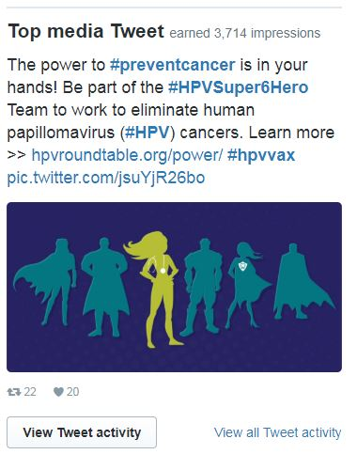
- Resource for Journalist – Lisa Paradis
  - Idea came together at our task group meeting last fall. Need for a resource that would point journalists to evidence-based information on HPV and HPV vaccine.
  - Aim is the be credible and accessible resource. Easy to use.
  - Current form – an edited document of various drafts.
  - Next steps: share with group and solicit feedback. Schedule a call to discuss.

- HPV Roundtable Updates
- Please create your member profiles on HPVRoundtable.org
- Visit http://hpvroundtable.org/power/
- Visit our NIAM Share-a-Thon page: http://hpvroundtable.org/niam-share-a-thon/

