Agenda
Aug. 1, 2018 at 2 p.m. ET
Communications Committee

ATTENDEES
Task Group Members:

Not able to join:

- Updates from members – Round Robin
- Updates on 2018 Power to Prevent HPV Cancer – Jennifer Sienko
- /Power - 3,521 pageviews July 2018 (34.37% of total pageviews)
- 1,711 Sessions (period of time a user is actively engaged with your website)
  - 83.46% of sessions were new sessions (estimation of first time visits)
  - 1428 New Users
  - 00:01:39 Average Session Duration
- 53.22% of people visiting HPVRoundtable.org entered through our /Power page
- Weekly emails for July
  - Total of 3,424 emails delivered in July
  - Week 1 – Announcement
    - 850 emails delivered
    - 2,228 total opens (354 unique opens)
    - 395 total forwards (102 unique forwards)
  - Week 2 – Office Staff
    - 847 emails delivered
    - 2,521 total opens (314 unique opens)
    - 424 total forwards (67 unique forwards)
  - Week 3 – Small Practice
    - 846 emails delivered
    - 1,471 total opens (311 unique opens)
    - 261 forwards (38 unique)
  - Week 4: Dental (in progress)
    - 881 emails delivered
    - 2,089 total opens (276 unique opens)
    - 644 Total forwards (57 unique forwards)
- Twitter
  - 50.9% increase in tweet impressions
  - 39.8% increase in profile visits
  - 52 mentions
  - 78 new followers
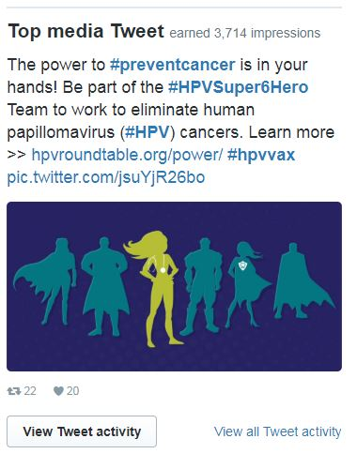
- Resource for Journalist

- HPV Roundtable Updates
- Please create your member profiles on HPVRoundtable.org

Tip Sheet for Journalist - Outline

Key Facts about HPV

HPV Vaccine Effectiveness

HPV Vaccine Recommendations

HPV Vaccine Uptake

HPV Infection

Images and Infographics

Data and Research

Interview Sources

Spokespersons

Additional Resources

Potential Story Ideas

