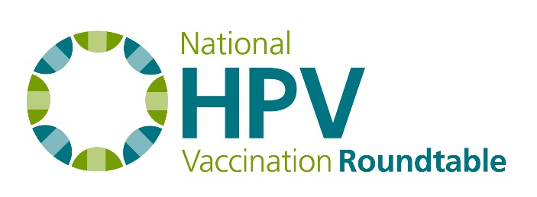
Best Practices Task Group Summary Notes
April 2017

Attendees: Paul Reiter (Chair), Noel Brewer, Mary Gerend, Melissa Gilkey, Sarah Kobrin, Rebecca Perkins, Debbie Saslow, Shannon Stokley, Jasmin Tiro
Staff: Jennifer Sienko

Best Practices Manuscript
The manuscript has been accepted by Academic Pediatrics and will be available on PubMed soon. The paper will be available as open access from the journal and everyone is encouraged to share with colleagues and present at conferences. Shannon will present the paper as part of a presentation at the NCI-designated Cancer Center meeting on HPV taking place May 11-12, in Charleston, SC. Noel suggested using a slide listing the top 12 gaps and opportunities.
Before the next call: Please brainstorm ideas to disseminate the paper. Current ideas are:
- Present at conferences
- HPV Roundtable E-newsletter, twitter, and Facebook accounts

Task Group Activity
This task group will help plan the scientific content of next HPV Vaccination Roundtable National Meeting (Feb. 26-27, 2018, Atlanta). There is time for 2(ish) hours of total content time. It is up to the task group to decide on the topics and format for the allotted time. With only two hours, the task group may want to pick a domain or space to focus on.
Some structure and format ideas include:
- A structure that allows for a lot of different speakers rather than one keynote speaker for half the time.
- Panel format
- A debate like the last Best Practices symposium
  - The audience enjoyed this
  - Need a good question/topic to frame debate – someone might need to take this on if the group decides to do a debate
Some topics and speakers include:
- Adam Dunn (Australia) - How clinical evidence (for HPV vaccine) is aggregated and distorted as it makes its way from clinical trials into the routine practice of clinicians and the wider population. Specific example is HPV vaccination on twitter.
- Researcher at Merck – integration of healthcare systems and what that means for vaccination payments.
- Kaiser (Bay Area) – Understanding what they did to increase HPV vaccination rates as a large integrated healthcare system.
- Research in Australia – combating HPV vaccine information on-line with a group of dedicated volunteers.

HPV Vaccination Roundtable Updates:
National Meeting Dates: We are pleased to announce the dates for the next National HPV Vaccination Roundtable meeting. Please hold February 27-28th, 2018 on your calendars. Task groups will meet the afternoon of 2/27/18, with an evening reception and dinner for all Roundtable members starting at 6 p.m. The meeting will be held from 9 - 4 p.m. on 2/28/18.

Task Group work:

Communications:
- Engage Your Communication Colleagues for May 8th Call: A new communications package targeting adolescent providers, “You’ve Got the Power to Prevent Cancer” will be revealed on a Roundtable Communications Showcase on May 8 at 2 p.m. ET. Please share registration link with communication colleagues in your organization: http://acswebmeetings.adobeconnect.com/showcase/event/event_info.html.

- Call for Social Media Partnerships with Clinical Partners: Qualifying organizations with existing Facebook accounts will receive free customized ads aligned to the campaign. Contact jennifer.sienko@cancer.org if your organization is interested.

- HPV Vaccination Roundtable Facebook Group: a new private Facebook group to allow you to easily connect with colleagues and quickly share information across the group. The goal of the group is to be an ongoing resource for accurate, timely news about HPV vaccination and education projects. You can ask to join at https://www.facebook.com/groups/HPVroundtable/.

State Coalitions & Roundtables Task Group Hosting Midwest Listening Session May 16-17, 2017:
- Coalition leaders from seven states will join task group members for a dialog around successes, strengths and needs of their HPV state-level efforts. Built around the Iowa HPV and Cancer Conference, this multistate gathering will connect states, allow for idea exchange, and provide the task group with valuable input on how best to support HPV coalition work at the state level.
New website:
- We have released an RFP soliciting vendors to build a new website for the Roundtable. We will have something new and improved in the next 6 months!

