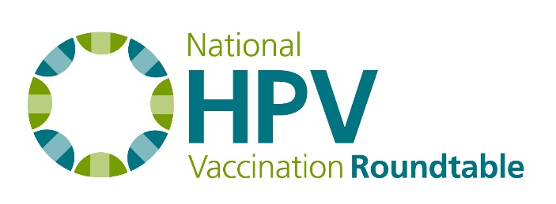
Best Practices Task Group Agenda
April 2017

Chair: Paul Reiter
Staff Liaison: Jennifer Sienko

Agenda
- Welcome and Roll Call
- HPV Vaccination Roundtable Updates
  - HPV Roundtable National Meeting dates: Feb. 27 – 28, 2018, in Atlanta
  - “You’ve Got the Power to Prevent Cancer” summer communications campaign
  - HPV Roundtable Member Facebook page
  - State Coalitions & Roundtables meeting in Iowa, May 16 – 17, 2017
  - New HPV Roundtable website RFP
- Update on status of Best Practices paper
- Next task group project: Scientific presentations at the National Meeting
- Schedule next call

