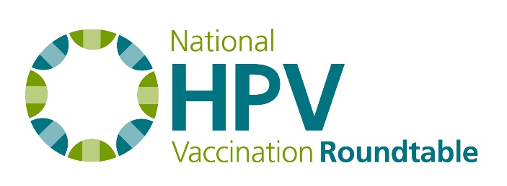
Best Practices Task Group Agenda
3 pm ET, May 25, 2017
Dial In: (917) 727-7985
Passcode: 400 9439

Chair: Paul Reiter
Staff Liaison: Debbie Saslow

Agenda
- Welcome and Roll Call
- Next task group project: Scientific presentations at the National Meeting
- Next call scheduled for June 15 at 3 pm ET

