PARTNER PACKAGE

Thank you for supporting HPV vaccination as cancer prevention!

The HPV Vaccination Roundtable’s HPV Prevention: Nurses Get It Done! toolkit is designed to empower nurses at all practice levels to get HPV vaccination done! With your help, we can empower the nurses in your network to increase HPV vaccination rates and help prevent HPV cancers.

The HPV Prevention: Nurses Get It Done! toolkit can be used in several different ways. Nurses can use the toolkit and materials to learn more about:
- HPV and HPV vaccine science
- Responding to commonly asked questions
- Techniques for managing shot discomfort experienced by patients

Additionally, Nurses at every practice level and other clinical leaders can use the toolkit as a training resource for their colleagues in their clinic, hospital or health system. The toolkit has built in knowledge checks and practice prompts to help nurses feel grounded in the information.

CAMPAIGN TIMELINE:
This campaign will run from February 2020 through June 2020. During this time, you are welcome to use all the copy when you want as well as make it sound more like you! You may also add your logo to any social images you use.

In this package, you will find:

Graphic Design Files 3
Newsletter Template – Nurses at all practice levels focus 4
Newsletter Template – Nurse Practitioner focus 5
Email Template – Nurses at all practice levels focus 6
Email Template – Nurse Practitioner focus 7
Social Media Posts Templates 8

Graphic Design Files

Download and use great images to share this campaign with your followers.

Email Header Templates – https://www.dropbox.com/sh/uhrnj2mqbnfghzy/AACivSugqDs1J5pZhc41QHL7a?dl=0
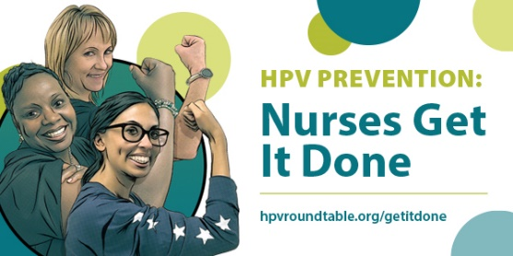

Social Images – https://www.dropbox.com/sh/16033iwbbfvfk1n/AACxGneXMQZhYT-cHoQEMOlKa?dl=0
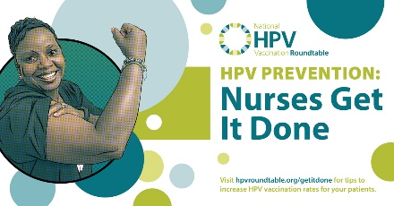 | 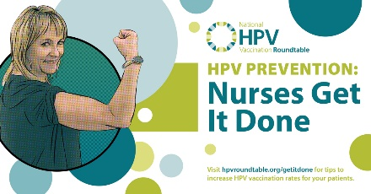 | 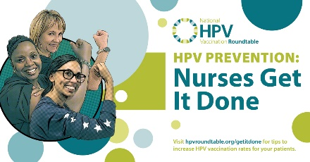
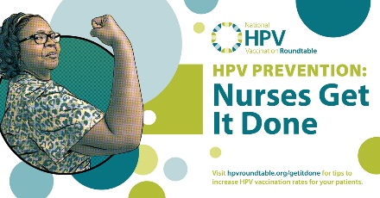 | 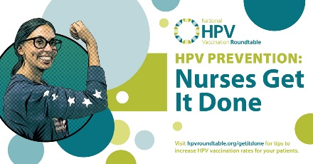

Flyer - https://www.dropbox.com/s/qml5116r6wktf48/HPV_NursesGetItDone_flyer_d04.pdf?dl=0

Web Banner - https://www.dropbox.com/sh/s24klq944mzoxw8/AAAZzUP43ZYGcAfjhWiJPosNa?dl=0

Newsletter Template – Nurses at all practice levels focus

HEADLINE: HPV Cancer Prevention: Nurses Get It Done!

BODY COPY:

With needle phobia on the rise and tough questions from some parents, we need all hands on deck to help preteens initiate and complete the HPV vaccination series! This is where nurses from all practice levels come in.

Nurses are critical members of the immunization team and have a powerful role to play in getting HPV vaccination done. The National HPV Vaccination Roundtable created the HPV Prevention: Nurses Get It Done! toolkit as an educational resource for nurses at all practice level to help empower confident initiation and completion of the HPV vaccination series.

Created with nurses in mind, the resources in this toolkit can be used by nurses at all practice levels to help answer HPV vaccine questions and manage shot discomfort for patients. Nurses are HPV vaccine champions that get HPV cancer prevention done!

Download the toolkit at >> https://hpvroundtable.org/getitdone/

Newsletter Template – Nurse Practitioner focus

HEADLINE: HPV Cancer Prevention: Nurses at every practice level Get It Done!

BODY COPY:

With needle phobia on the rise and tough questions from some parents, we need all hands on deck to help preteens initiate and complete the HPV vaccination series! This is where Nurses Practitioners come in!

Nurses Practitioners have higher rates of HPV vaccination uptake than any other health care provider and are uniquely positioned to educate and empower the entire clinical team to get HPV vaccination done. The National HPV Vaccination Roundtable recognizes nurses as powerful change agents within a clinical team and created the HPV Prevention: Nurses Get It Done! toolkit as a teaching resource to empower nurses at all practice levels to confidently initiate and complete the HPV vaccination series.

Created with input from the National Association of Pediatric Nurses Practitioners, the American Association of Nurses Practitioners, and the Centers for Disease Control and Prevention - this toolkit can be used by Nurses at every practice level to deliver evidence-based information on HPV and HPV vaccination in staff training. Nurses at every practice level are HPV vaccine champions that can help nurses at all practice levels get HPV cancer prevention done!

Download the toolkit at >> https://hpvroundtable.org/getitdone/

Email Template – Nurses at all practice levels focus

Dear Nursing Colleague,

With needle phobia on the rise and tough questions from some parents, we need all hands on deck to help preteens initiate and complete the HPV vaccination series! This is where nurses at all practice levels come in.

Nurses are critical members of the immunization team and have a powerful role to play in getting HPV vaccination done. The National HPV Vaccination Roundtable created the HPV Prevention: Nurses Get It Done! toolkit as an educational resource for nurses at all practice levels to empower confident initiation and completion of the HPV vaccination series.

With this toolkit, nurses at all practice levels will have easy access to educational materials including:

- HPV 101 for immunizers
- Answers to commonly asked questions about HPV vaccination
- Tips and tools to help manage shot discomfort
- Knowledge checks and practice prompts to help learners feel confident in what they learned

Get the HPV Prevention: Nurses Get It Done! toolkit today and get HPV cancer prevention done.

DOWNLOAD: https://hpvroundtable.org/getitdone/

Email Template – Nurse Practitioner focus

Dear Nurse Practitioner Colleague,

With needle phobia on the rise and tough questions from some parents, we need all hands on deck to help preteens initiate and complete the HPV vaccination series! This is where Nurses Practioners come in!

Nurse Practitioners have higher rates of HPV vaccination uptake than any other health care provider and are uniquely positioned to educate and empower the entire clinical team to get HPV vaccination done. The National HPV Vaccination Roundtable recognizes nurses as powerful change agents within a clinical team and created the HPV Prevention: Nurses Get It Done! toolkit as a teaching resource to educate and empower nurses at all practice levels to confidently initiate and complete the HPV vaccination series.

Created with input from the National Association of Pediatric Nurses Practitioners, the American Association of Nurses Practitioners, and the Centers for Disease Control and Prevention - this toolkit can be used by Nurses at every practice level to deliver evidence-based information on HPV and HPV vaccination in staff trainings with nurses at all practice levels.

With this toolkit, nurses at every practice level will have easy access to educational materials designed to help empower nurses to initiate and complete the HPV vaccine series, including:

- HPV 101 for immunizers
- Answers to commonly asked questions about HPV vaccination
- Tips and tools to help manage shot discomfort
- Knowledge checks and practice prompts to help solidify the learning and enable learners to feel confident in what they learned

Get the HPV Prevention: Nurses Get It Done! toolkit today and empower the nurses you work with to get HPV cancer prevention done.

DOWNLOAD: https://hpvroundtable.org/getitdone/

Social Media Posts Templates

Below are a few social media posts the National HPV Vaccination Roundtable is using to promote the HPV Prevention: Nurses Get it Done! toolkit. You are encouraged to use these messages on your social media channels and are welcome to edit them to make them sound more like you.

FACEBOOK

HPV vaccination IS cancer prevention and nurses get it done! Nurses are critical to ensuring preteens start the HPV vaccine series. Download the National HPV Vaccination Roundtable’s HPV Prevention: Nurses Get It Done! toolkit to learn how to talk to parents about the HPV vaccine. https://hpvroundtable.org/getitdone/

HPV Vaccination Tip: Talking to parents about the HPV vaccine shouldn’t take long. Get tips on how to effectively recommend the HPV vaccine for your patients. https://hpvroundtable.org/getitdone/

Nurses: become an HPV vaccination champion! With the National HPV Vaccination Roundtable’s HPV Prevention: Nurses Get It Done! toolkit, gain tools and resources to increase your HPV vaccination rates. We know nurses get it done! https://hpvroundtable.org/getitdone/

Nurses are amazing immunizers and already do so much to protect their patients from vaccine preventable diseases, including HPV. However, we know more can be done. Download the National HPV Vaccination Roundtable’s HPV Prevention: Nurses Get It Done! toolkit today for tips and resources on how to help patients start and finish their HPV vaccine series. https://hpvroundtable.org/getitdone/

DYK: Less than half (48.6%) of preteens in the United States are up to date on their HPV vaccinations. Download the National HPV Vaccination Roundtable’s HPV Prevention: Nurses Get It Done! toolkit today for tips and resources on how to help patients start and finish their HPV vaccine series. https://hpvroundtable.org/getitdone/

The National HPV Vaccination Roundtable created the HPV Prevention: Nurses Get It Done! toolkit to help nurses at all practice levels feel empowered and confident in their HPV vaccine knowledge. Download the toolkit today for tips and resources on how to help patients start and finish their HPV vaccine series. https://hpvroundtable.org/getitdone/

TWITTER

Nurses are critical to ensuring preteens start the HPV vaccine series. Get the @hpvroundtable HPV Prevention: Nurses Get It Done! toolkit to learn how to talk to parents & preteens about getting the #HPVvax. https://hpvroundtable.org/getitdone/ #NursesGetItDone #vaccineswork #vaccination #HPVvaccine #2Shots2StopCancer

#Nurses - Talking to parents about the HPV vaccine shouldn’t take long. Get tips on how to effectively recommend the #HPVvax to parents. https://hpvroundtable.org/getitdone/ #NursesGetItDone #vaccineswork #vaccination #HPVvaccine #2Shots2StopCancer

#Nurses - Become an #HPV vaccination champion! Get tools and resources from @hpvroundtable to increase #HPVvax rates in preteens to prevent cancer. We know nurses can get it done! https://hpvroundtable.org/getitdone/ #NursesGetItDone #vaccineswork #vaccination #HPVvaccine #2Shots2StopCancer

#Nurses - Less than half (48.6%) of preteens in the U.S. are up to date on their #HPV vaccinations. Get tips & resources from @hpvroundtable to help patients effectively complete the #HPVvax series. https://hpvroundtable.org/getitdone/ #NursesGetItDone #vaccineswork #vaccination #HPVvaccine #2Shots2StopCancer

23% of individuals who didn’t get a flu shot avoided it because they don’t like needles. Learn how nurses at all practice levels can manage needle discomfort in preteens getting the #HPVvax. https://hpvroundtable.org/getitdone/ #NursesGetItDone #vaccineswork #vaccination #HPVvaccine #2Shots2StopCancer

